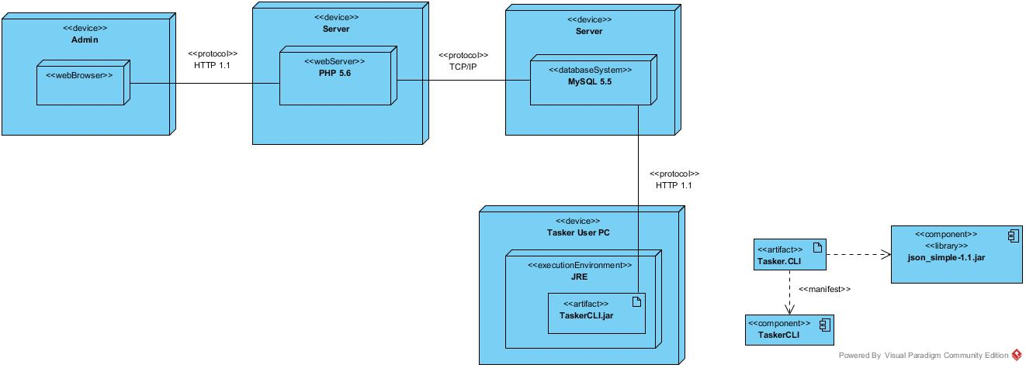**UML Deployment Diagram**

Admins can access the TaskerMAN website via a web browser. The TaskerMAN website will communicate with the web server using the HTTP 1.1 protocol, although HTTPS could be used for better security. This communication will provide information to the admin such as all users and their tasks and allow the admin to allocate new tasks. The database system uses MySQL 5.5 and communicates with the web server using the TCP/IP protocol and also the TaskerCLI program via HTTP 1.1. A regular tasker user will run the TaskerCLI program in the JVM (Java virtual machine) using JRE (Java runtime environment). The TaskerCLI.jar consists of the TaskerCLI component and the JSON external library.

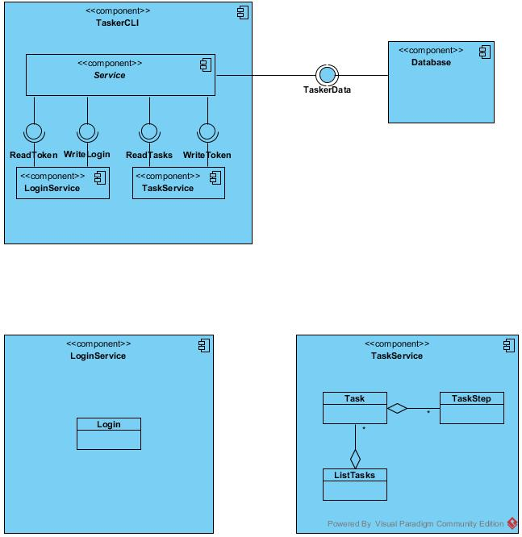

**UML Component Diagram**

The TaskerCLI component contains two Service implementations; LoginService and TaskService. These services communicate with the database system, exchanging TaskerData which can include (but not limited to) information such as login credentials or user tasks. The LoginService consists only of the Login class and the TaskService contains a Task class which has many TaskSteps and ListTasks will produce those Tasks.